**Subhan Bin Yousaf**

**Section B**

**481281**

**FOP Lab Manual 5**

**Home Tasks**

**Home Task 1 :**

#include <iostream>

using namespace std;

int main() {

int a,b, c, d, h, l;

cout << "Enter First number = ";

cin >> a;

cout << "Enter Second number = ";

cin >> b;

c = a;

d = b;

while (d != 0)

{

h = d;

d = c % d;

c = h;

}

h = c;

l = (a * b) / h;

cout << "LCM is = " << l;

return 0;

}

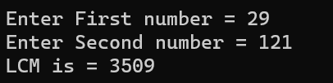

**Home Task 2 :**

#include <iostream>

using namespace std;

int main () {

int n, a, d,sum;

cout << "Enter number of terms : " << endl ;

cin >> n;

cout << "Enter first term : "<< endl;

cin >> a;

cout << "Enter common difference : " << endl ;

cin >> d;

sum = (n * (2 * a + (n - 1) * d)) / 2;

cout << "Sum of the arithmetic progression series: " << sum << endl; return 0;

}

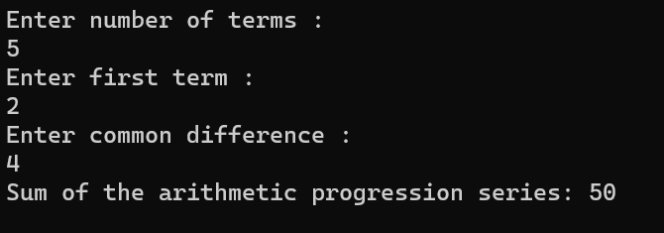

**Home Task 3 :**

#include <iostream>

using namespace std;

int main () {

int a;

cout << "Enter the number of rows = ";

cin >> a;

for (int i = 1; i < a; i++)

{

for (int j = i; j <= a; j++)

{

cout << " ";

}

for (int k = 1; k < i; k++)

{

cout << "* ";

}

for (int l = 1; l <= i; l++)

{

cout << "* ";

}

cout << "\n";

}

for (int i = 1; i <= a; i++)

{

for (int m = 1; m <= i; m++)

{

cout << " ";

}

for (int n = i; n < a; n++)

{

cout << "* ";

}

for (int o = i; o <= a; o++)

{

cout << "* ";

}

cout << "\n";

}

return 0;

}

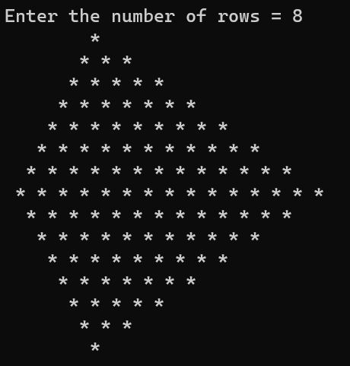

**Home Task 4 :**

#include <iostream>

using namespace std;

int main(){

int a,b,c;

string r = "";

cout << "Enter a number = ";

cin >> a;

b = a;

c = a;

while (b > 0)

{

c = b % 2;

r = char(c + '0') + r;

b = b / 2;

}

cout << "The binary number is = "<<r << endl;

return 0;

}

